****Московский государственный технический университет им. Н.Э. Баумана  
Кафедра «Системы обработки информации и управления»

Лабораторная работа №7  
по дисциплине  
«Методы машинного обучения»  
на тему

# «Алгоритмы Actor-Critic»

Выполнил:  
студент группы ИУ5-23М  
Чжэн Сяохуэй

Москва — 2024 г.

**1. Цель лабораторной работы**

ознакомление с базовыми методами обучения с подкреплением на основе алгоритмов Actor-Critic.

**2. Задание**

* Реализуйте любой алгоритм семейства Actor-Critic для произвольной среды.

**3. текст программы**

import gym

import torch

import torch.nn as nn

import torch.optim as optim

import numpy as np

import matplotlib.pyplot as plt

# Actor-Critic网络

class ActorCritic(nn.Module):

def __init__(self, input_dim, action_dim):

super(ActorCritic, self).__init__()

self.fc = nn.Linear(input_dim, 128)

self.policy = nn.Linear(128, action_dim)

self.value = nn.Linear(128, 1)

def forward(self, x):

x = torch.relu(self.fc(x))

policy_dist = torch.softmax(self.policy(x), dim=-1)

value = self.value(x)

return policy_dist, value

# Hyperparameters

env = gym.make('CartPole-v1')

input_dim = env.observation_space.shape[0]

action_dim = env.action_space.n

lr = 0.01

gamma = 0.99

episodes = 1000

# 初始化网络和优化器

model = ActorCritic(input_dim, action_dim)

optimizer = optim.Adam(model.parameters(), lr=lr)

# 训练过程

def train():

episode_rewards = []

for episode in range(episodes):

state, info = env.reset()

state = torch.tensor(state, dtype=torch.float32).unsqueeze(0)

done = False

total_reward = 0

while not done:

policy_dist, value = model(state)

action = np.random.choice(action_dim, p=policy_dist.detach().numpy().flatten())

next_state, reward, done, _, _ = env.step(action)

next_state = torch.tensor(next_state, dtype=torch.float32)

_, next_value = model(next_state)

# 计算优势

advantage = reward + (1 - done) * gamma * next_value - value

# 损失函数

policy_loss = -torch.log(policy_dist.squeeze(0)[action]) * advantage

value_loss = advantage ** 2

loss = policy_loss + value_loss

# 反向传播

optimizer.zero_grad()

loss.backward()

optimizer.step()

state = next_state

total_reward += reward

episode_rewards.append(total_reward)

if (episode + 1) % 100 == 0:

print(f'Episode {episode + 1}, Total Reward: {total_reward}')

return episode_rewards

# 运行训练并绘制结果

rewards = train()

plt.plot(rewards)

plt.xlabel('Episode')

plt.ylabel('Total Reward')

plt.title('Training Performance')

plt.show()

def play_agent():

env2 = gym.make('CartPole-v1', render_mode='human')

state, info = env2.reset()

state = torch.tensor(state, dtype=torch.float32).unsqueeze(0)

done = False

while not done:

policy_dist, _ = model(state)

action = torch.multinomial(policy_dist, 1).item()

next_state, reward, done, _, _ = env2.step(action)

env2.render()

state = torch.tensor(next_state, dtype=torch.float32)

if __name__ == '__main__':

# 训练代理

# train()

# 使用训练好的代理进行演示

play_agent()

4. экранные формы с примерами выполнения программы.

Episode 100, Total Reward: 56.0

Episode 200, Total Reward: 94.0

Episode 300, Total Reward: 103.0

Episode 400, Total Reward: 139.0

Episode 500, Total Reward: 20.0

Episode 600, Total Reward: 94.0

Episode 700, Total Reward: 497.0

Episode 800, Total Reward: 843.0

Episode 900, Total Reward: 143.0

Episode 1000, Total Reward: 184.0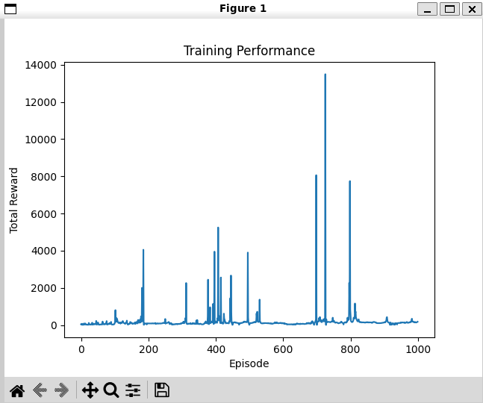

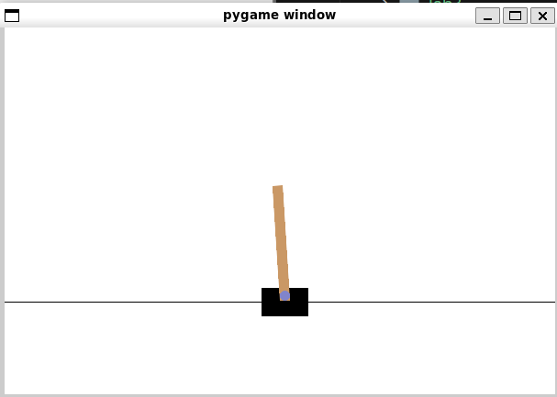

**Список литературы**

[1] Гапанюк Ю. Е. COURSE_MMO_SPRING_2024// GitHub. –– 2024. –– Режим доступа: https://github.com/ugapanyuk/courses_current/wiki/COURSE_MMO_SPRING_2024

[2] <https://www.kaggle.com/datasets>